Calculus 2 Lecture 9.4: The Comparison Test for Series and The Limit Comparison Test

IDEA:
Compare one series to another where you already know convergence/divergence.
(Geometric, P-series, harmonic, etc.

Suppose 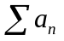 and 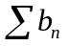 are series with positive terms

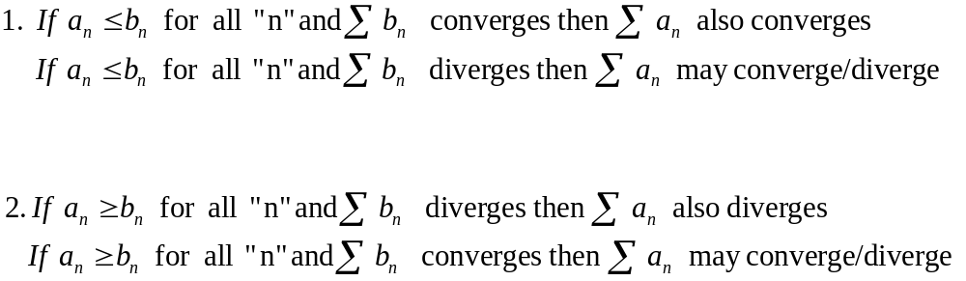

Example
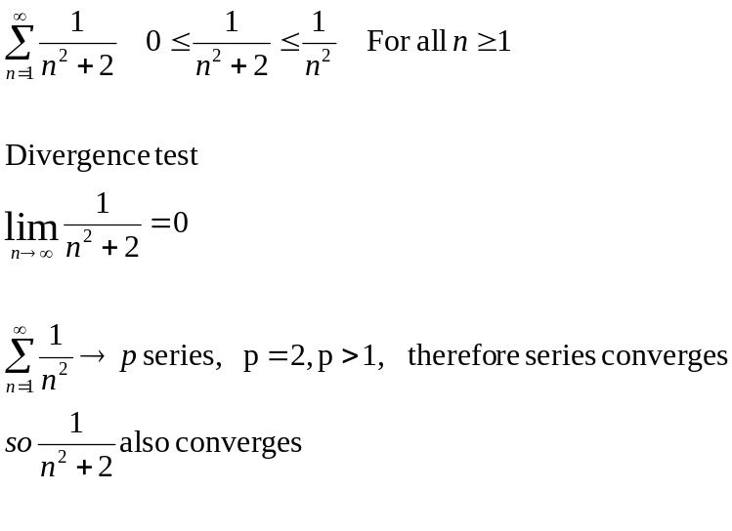

Example
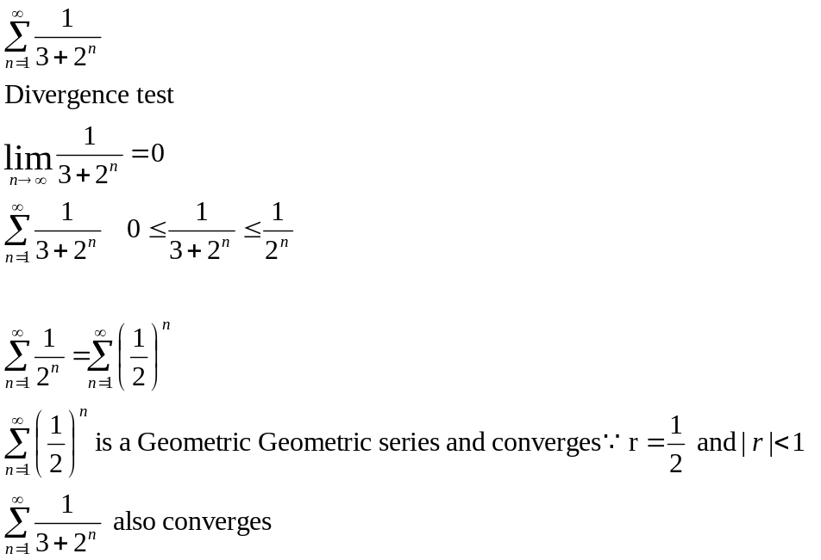

Example
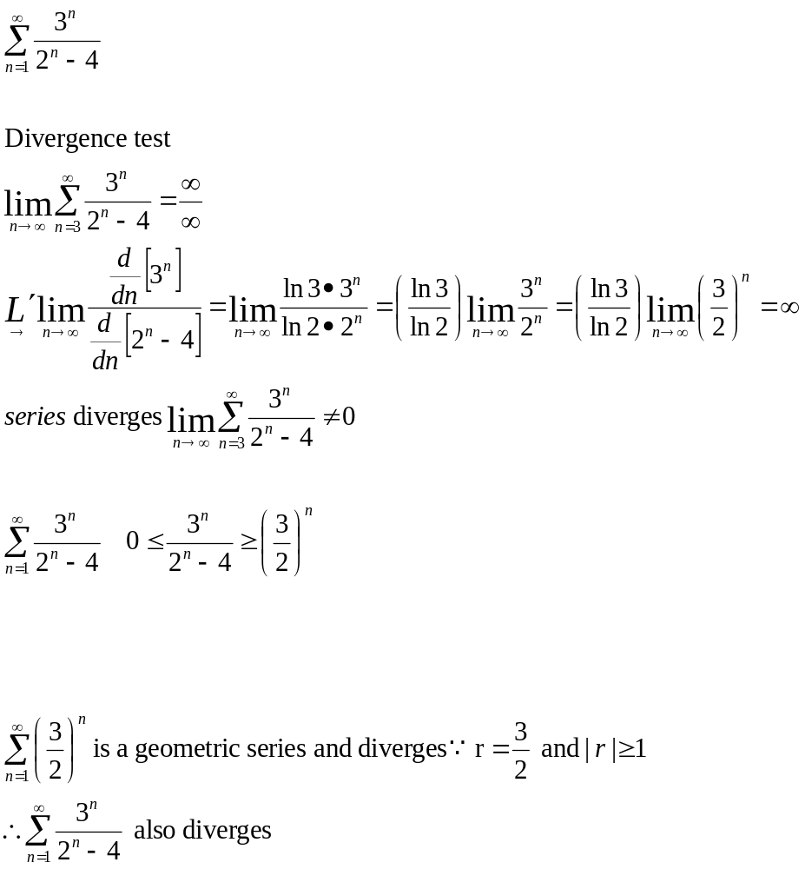

Limit Comparison Test
IDEA:
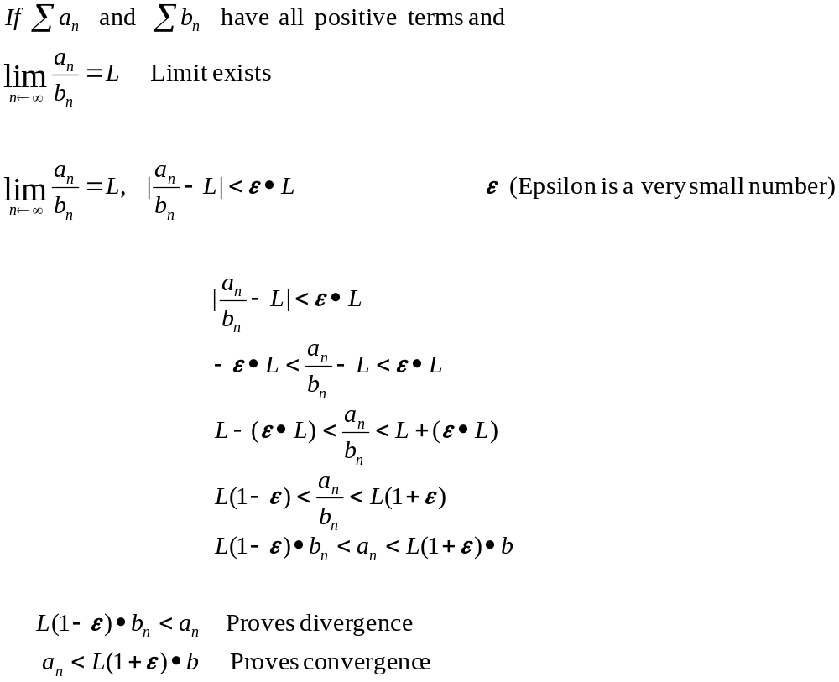

Then both series either converge or diverge

Example
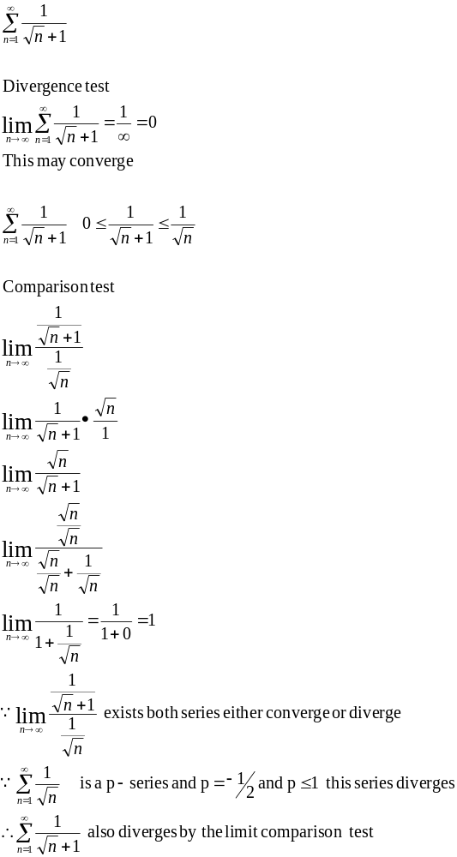
Example

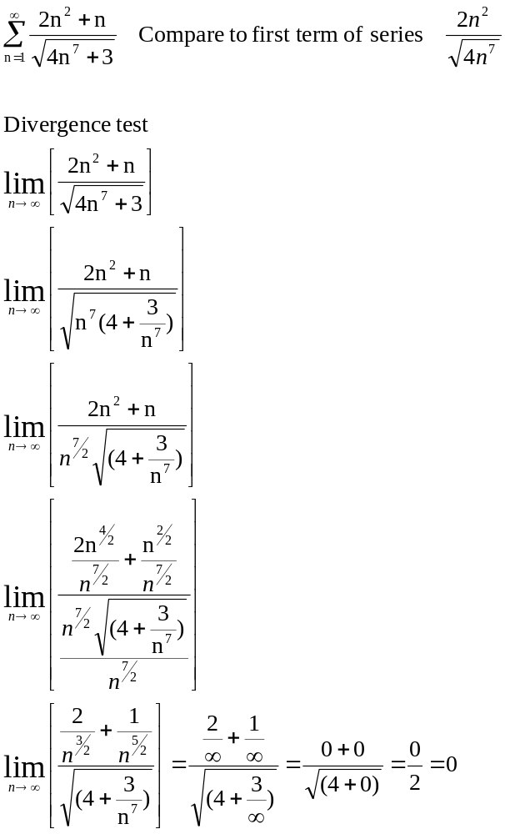

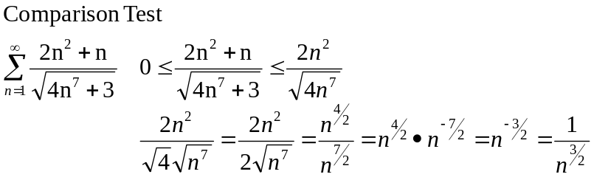

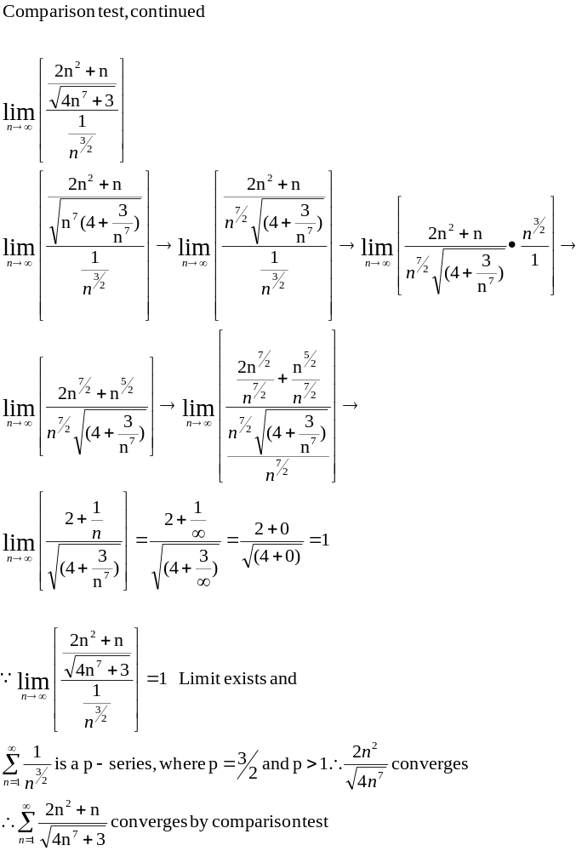

Example
